# Two Very Cute Tree Huggers

Abby and Gwen sampled several different trees to climb during the week. From our back yard to various trees in local parks, they sure had some fun.

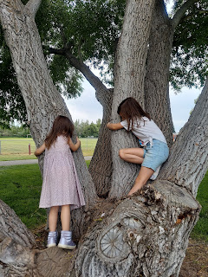

Abby's enthusiasm reminded me of the times I climbed some trees myself, as a child. If left to my own choice, I probably wouldn't have climbed as many on my own, but I often followed my sister, Charmaine's lead. She has always been an avid tree climber, up until recently when she fell out of a tree at 52 years old, breaking her wrist and bruising her body pretty badly. All that aside (and she has since healed up nicely), as a young girl, I just wanted to do what my older sister did, and to be wherever she was. If she wanted to scale a tree, that meant I would do my best to climb as high as I could, too . . . until I got scared or stuck. Thankfully, she was kind enough to help me down at that point. If she had already climbed all the way down, I remember many times when she would hoist herself back up in order to work her way to wherever I was stuck. Sometimes I would be crying, but she would always calmly and methodically coach me on the best footing and branches to use in order to get down, one step at a time. What a wonderful big sister!

Last Sunday, June 25th:

After church, Benson, Amber, the girls and I all drove up to Rigby to have a late lunch with Grandpa Harmon and Bev. Bev was a professional chef for several years, so when she invites you to a meal, you come running!! She made a delicious chicken pot pie, with rolls and vegetables, and I brought a Caesar salad with homemade Caesar dressing and croutons (Amber gets the credit for the croutons). Bev also made the BEST banana cream pie that I've ever had in my entire life.

After lunch, we went downstairs to sort through the rest of the children's books that Coy had kept all these years. Several family members had already snagged a few books when they came for the funeral, but there were still so many on those bookshelves in the basement . . . Grandpa (Phil) has been anxious about so much stuff still sitting around the house, so Bev has been boxing up things every day to be hauled off to charity (such as Coy's clothes, old DVD's, several even older VHS movies, etc).

Bev offered to read one of Coy's favorite stories to Abby and Gwen. It was so sweet of her to do that.

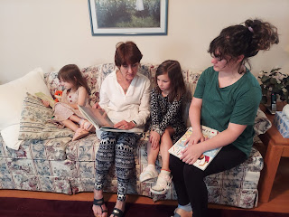

She also offered popsicles to the girls, which they happily gobbled up on the back porch.

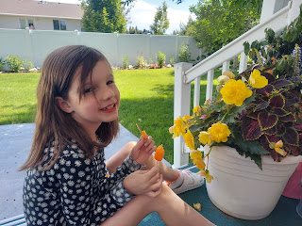

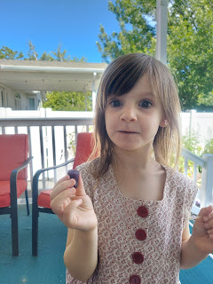

Monday, June 26th:

The day began with trees to climb in the back yard. From top to bottom: Benson, Abby, and Gwen (on the ground).

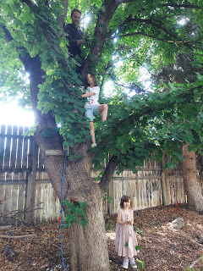

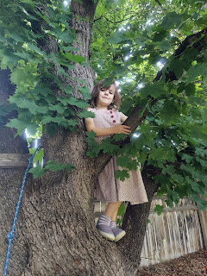

Oh Gwen, with your silly giggles . . . ha ha

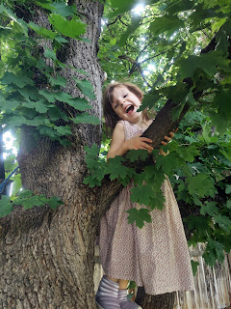

Abby was very adventurous, wanting to challenge herself, while still being cautious and patient at the same time, carefully choosing which direction and which branch to use as a hoist for her next step.

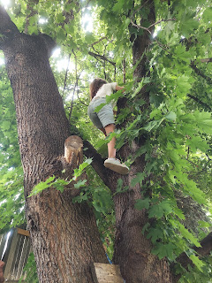

Soon, though, just like when I got stuck or scared as a little girl, Abby needed a little help to get down, too. Thankfully, Benson was right there to assist.

Video of Abby's descent Part 1: (1 minute, 15 seconds)

https://photos.app.goo.gl/98uhqLX9qBGH6Mt5A

Video of Abby's descent Part 2: (33 seconds)

https://photos.app.goo.gl/HNuZLwQejk4MHUjY8

Note that she ran screaming toward the house, yelling something like, "I'll never climb a tree ever again!" But that wasn't true, as you will soon see.

We had a picnic in the park for lunch. We chose McCowin Park in Ammon because it was close. We picked up some food at Wendy's and spread out my beach blanket and had a lovely time.

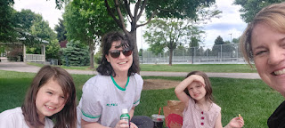

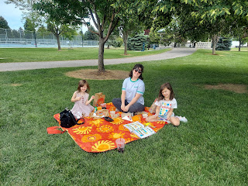

Even though we played on the playground a bit, the real star of the show was the great selection of climbing trees!!

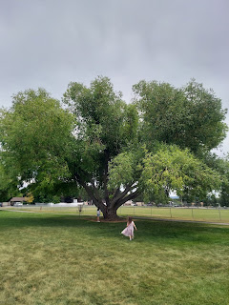

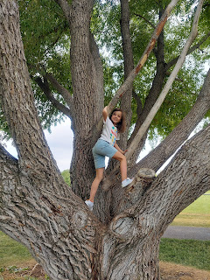

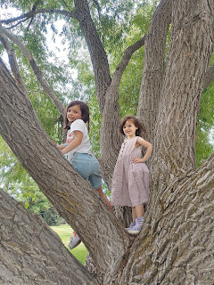

This is where the idea of Tree Huggers came from (for this post) . . . ha ha

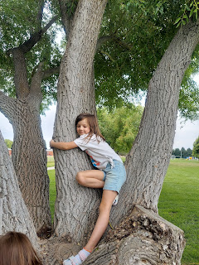

Later that afternoon, we drove a few miles north to visit Bear World. While it is a bit expensive, you get a lot for your money. First, you drive around the park and can see several species of wildlife: elk, mountain goats, bison, deer, and BEARS. They have over 60 grizzlies and black bears in the park. There is no stopping allowed as you drive through the bear enclosure . . . I wonder why . . .

This was the elk area . . .

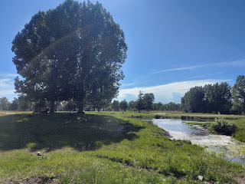

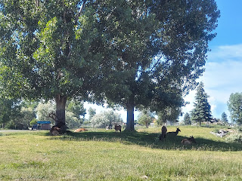

Also, there is one rare white elk in the park . . .

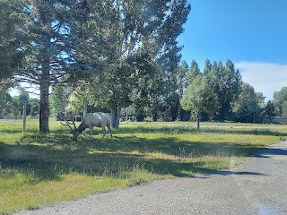

We got a closeup view of Bambi . . .

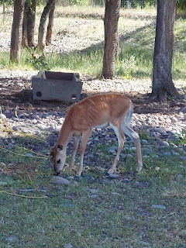

The white elk was quite impressive . . .

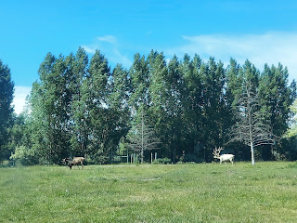

Video as we drove right next to the white elk: (15 seconds)

https://photos.app.goo.gl/ncM12jnETLWtKfqh9

The bears were mostly just sleeping or lazily lying around as we drove through . . .

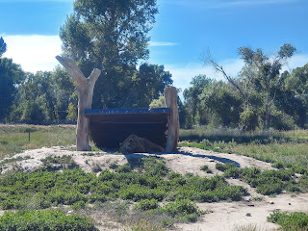

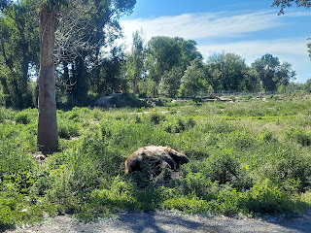

Video as we passed a bear munching on something right next to the road: (13 seconds)

https://photos.app.goo.gl/cH5WXkHGNNq5oSZ78

Once we drove through the whole park, we parked the car next to the gift shop, which was the entrance to the rest of Bear World.

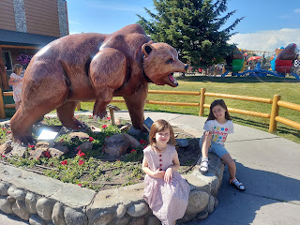

I thought these signs were cute, especially the one that says, "Let's find some beautiful place to get lost."

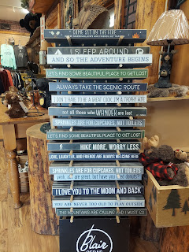

Behind the gift shop is the enclosure with all the baby bears. If you want to pay an additional $75 (choke), you can bottle feed the bears at one of their scheduled feeding times per day. We were lucky to walk by just as the 5:00 feeding was beginning. We had a great view and could take pictures and videos for free. :)

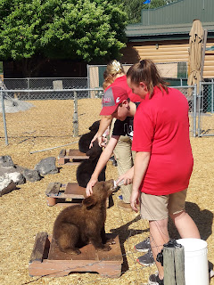

Video #1 of the baby bears eating: (33 seconds)

https://photos.app.goo.gl/ms8Byyu9xbU41oxm7

Video #2 of the baby bears eating: (16 seconds)

https://photos.app.goo.gl/hyeUXh7Eqoe5kjfZ9

It appears that just the Papa Bear was missing in this photo . . . (Abby, Amber and Gwen)

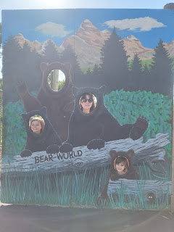

There are a few rides to enjoy as well. Amber and the girls rode inside the bear wearing green on this "teacup twirl" sort of ride. That would have made me too dizzy . . .

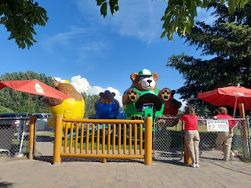

We rode the roller coaster next, but didn't get any photos of that. Abby didn't feel comfortable riding it, so she sat on the bench and waited for us. After the roller coaster, we all rode the ferris wheel together.

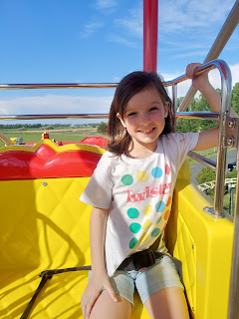

We could see the entire Jurassic Creek enclosure from the ferris wheel. This dinosaur area is brand new for 2023 and was absolutely amazing. (more on that in a minute)

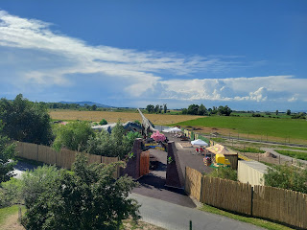

Amber rode with Gwen, while I shared a basket with Abby.

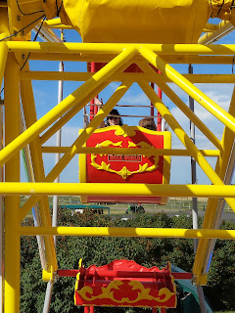

Abby and Gwen rode on this gentle uppy-downy ride multiple times. We had to convince them to get off finally, ha ha.

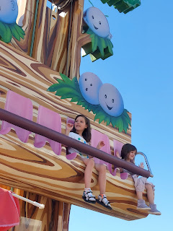

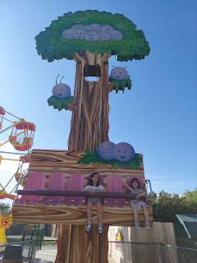

Gwen also talked me into riding the roller coaster one more time, too.

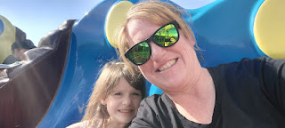

Then we scurried over to Jurassic Creek . . . where we had to pick our jaws up off the ground more than once because it was so incredibly amazing.

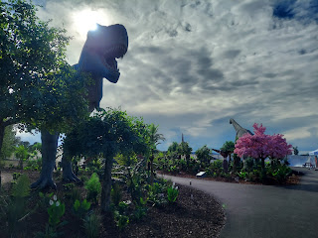

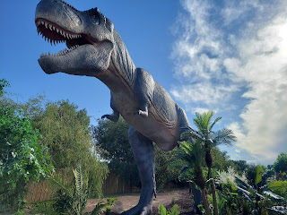

Video of the giant T-Rex as we entered: (13 seconds)

https://photos.app.goo.gl/SDTHz9ZzSr3L8UUP7

Abby riding a dinosaur . . .

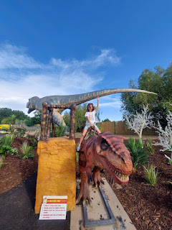

Gwen's rapturous expression was simply priceless . . .

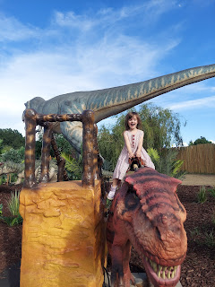

Two darling Pterodactyl babies hatching . . .

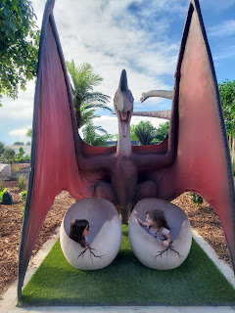

Abby's terrified face inside the dinosaur mouth . . . such perfect acting!! She's so awesome.

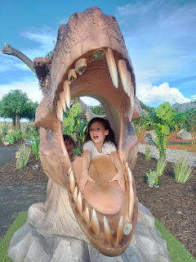

Video of the Triceratops next to the Brachiosaurus: (14 seconds)

https://photos.app.goo.gl/guk6UeUqWHSxoPVv6

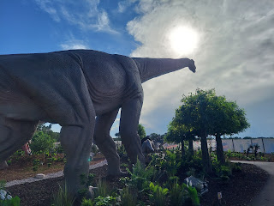

Another dinosaur ride . . . it's only 25 cents for a very life-like experience!!

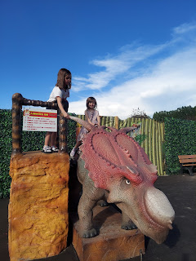

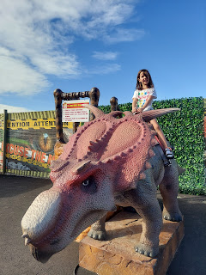

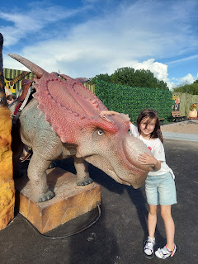

Near the exit was a giant sand area where the kids can dig for fossils and dinosaur bones. If the park wasn't about to close soon, I'm sure they would have played in the sand for a lot longer . . .

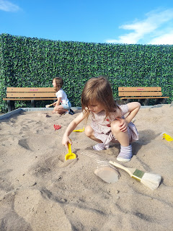

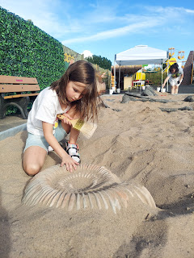

Everything was so well done. The dinosaurs were built incredibly well and each of them delivered some pretty amazing sounds and movements. The flowering trees and other landscaping were so beautiful, too.

L to R: Gwen, Amber, and Abby

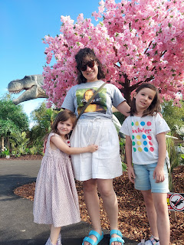

We spent a little bit of time in the gift shop before they closed, where the girls each chose a stuffed animal, and Amber found some great deals on hoodies for their family prior to a big family campout. Everyone found something to bring home as a memento, and we all oohed and aahed over the whole experience on the drive home.

Near the end of the day, my mom shared the sweetest picture of her mom, my Grandma Doris, who turned 102 that same day!!

L to R: Grandma Doris (the birthday girl), my Mom, and my cousin Lynnette (Uncle Wayne's granddaughter)

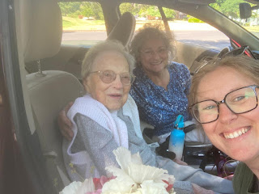

I can't believe the long life she's lived. I've tried to piece together all the things that have been invented or that have happened in the past 102 years . . . it's a lot. But here are a handful:

Women were finally allowed to vote

Prohibition

The Spirit of St. Louis successfully flew across the Atlantic Ocean

Amelia Earhardt flew across the Atlantic Ocean

The Great Depression

WWII and the Holocaust

McDonald's is founded

Baby Boom after the war

Korean War

DNA discoveries and new understanding of how it works

Berlin Wall built

JFK assassinated

Vietnam War

Civil unrest and Civil Rights movement

First man in space (the year Scott was born)

Roe vs Wade

Personal Computers are invented

The internet is born (1983)

Berlin Wall comes down

Amazon.com is born (1994)

Cloning is discovered

Google begins

9/11 in 2001

Iraq War

Facebook begins (2004)

The Great Recession

First African American President is elected

Epic tsunamis, earthquakes, fires and other natural disasters

Covid-19 pandemic

And a "few" other newsy things

I'm so grateful for all the years I've been able to know my Grandma and to learn from her and spend time with her. From what I heard, she had a wonderful birthday. :)

Tuesday, June 27th:

We got to see Avery again, hooray!! Kylie brought her over to see us, which allowed Amber, Abby and Gwen to meet her in person for the first time. Avery was MOST excited to see her daddy, Benson, though. She ran over to him time and time again, with joy on her face. That made me so happy.

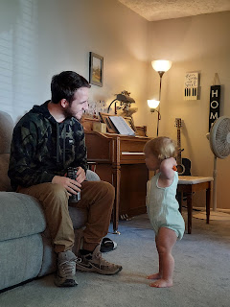

Avery is touching Abby's new stuffed animal from Bear World (a polar bear with a paw that functions as a mini flashlight). Abby was very sweet with Avery. Gwen was a little less enamored with her cousin, especially as Avery unknowingly stepped on the train set that she was putting together . . .

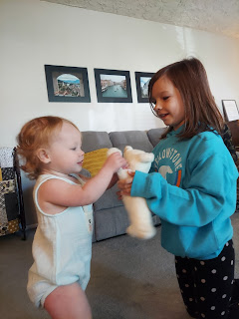

Avery was a bundle of energy, running around exploring everywhere. To entice her to come snuggle with Amber for a minute, we gave her a bowl of Reese's puffs cereal to munch on while Amber held her.

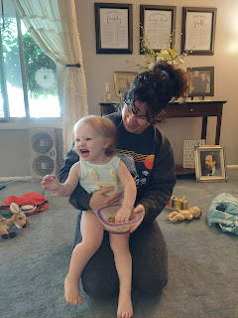

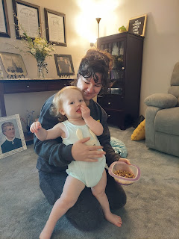

She was a wiggle worm, though, haha. Time to run around some more . . .

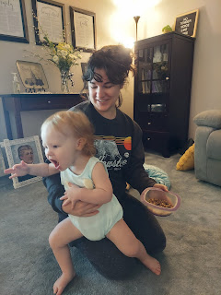

Avery and Benson standing next to their ancestors . . . XOXO

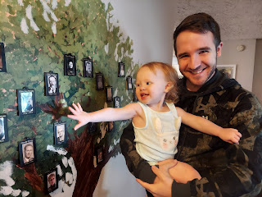

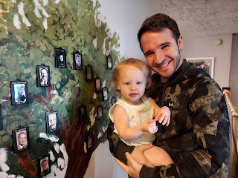

After Kylie and Avery left, Jasmine came over to visit for a while. Dang it, I didn't get any photos, but we had a wonderful time. She stayed for a couple hours, which allowed us to get all kinds of caught up on life's happenings. They just recently bought a couple of acres down in St. Johns, Arizona and are getting situated there. I am so happy for her little family and how they are being blessed. They are only about 45 minutes east of Show Low, where our niece Vanessa and her family live. So next time we go down to see them, it will be a "two-fer"!! How fun.

Amber took Abby up to Rigby during our visit with Jasmine, because Abby was finally old enough to participate in her first ever Cousin Camp. Each summer, Weston's parents invite all the grandchildren ages 8 and up to come stay with them and have some really amazing experiences together. This year, because there were eight children in all that were old enough, Kathy sat down to make a very organized schedule of events. On Day One, they divided up into 4 teams of 2, chose a team name, and then had some team-building activities and games. They intended to have a cookout in the back yard with s'mores, but a storm rolled in so they ordered pizza instead and watched a movie indoors.

Other activities included a KID WASH, ha ha. I saw a picture of it on Instagram . . . Kathy posted these next photos on her account.

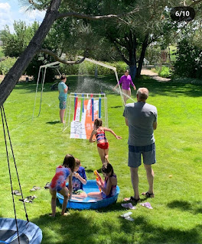

Kathy taught her grandchildren a watercolor painting class . . .

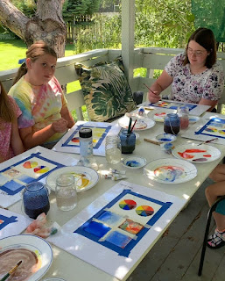

Abby had some quality time with her "twin", Natalie, a cousin from Utah who was born on the exact same day as her (on April Fool's Day).

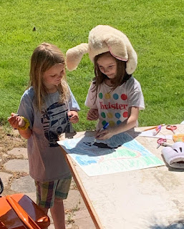

Kathy shared on Instagram that each team performed their own skits, played night games, she recorded their height as she does each year, and everyone wrote in their journal. She keeps the journals and then each year the grandchildren add to it when they come. HOW FUN!!! I always learn so many great ideas from her. She is such an amazing grandma!!

Here are the 2023 Cousin Camp attendees, including Natalie and Abby in the front row as the newest members.

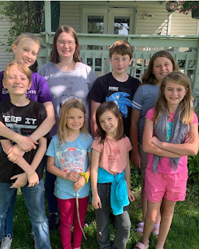

Meanwhile, Gwen was rather cold in our odd month of June weather lately . . . so she bundled up and hung out with us on the pack patio.

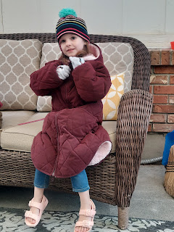

The City of Idaho Falls has been doing a summer-long project, which includes our neighborhood, by installing optic fiber underground to improve the internet capabilities. It's a messy job and it took several days with the workers coming in and out of our back yard, but it appears to be done now, as of this writing. Here is the peak of the mess in the back corner . . .

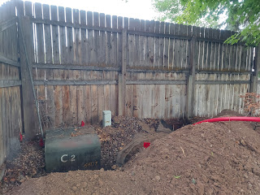

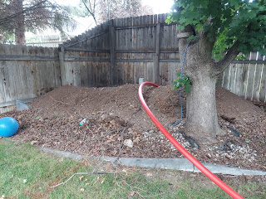

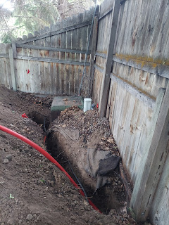

Hopefully this will all be worth it in the future. It should be . . .

Wednesday, June 28th:

I finally had a good chat with this handsome guy.

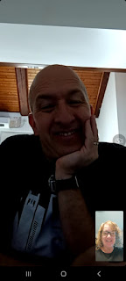

Between busy stuff happening here and busy stuff happening with him over in Italy, we spoke maybe 5-10 minutes total over 3-4 days. He got a colonoscopy on this particular day, which was a relief to get that over and done with. I can't believe the rigamaroll you have to do in the 5 or so days leading up to the procedure!! He spent the entire prior day just going in and out of the bathroom. We didn't even get to talk on the phone that day.

He also had a scope sent down his throat to look at the trouble in his esophagus again. So far we don't have any devastating news, so that's good. I hope that all will be well for him.

Benson worked hard to cook us up some amazing ribs all afternoon. He used a rub on one rack of ribs and a sauce/rub combo on the other rack. They were both equally delicious!!

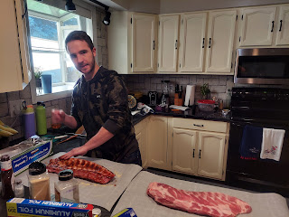

While Benson worked on the ribs and Amber ran some errands, Gwen and I went roller skating.

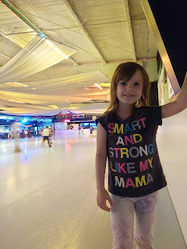

The rink had a shortage of "helpers" to rent when we got there, so Gwen had to resort to holding my hand or using the railing for support. She was much more nervous than the last time we went skating, which was down in Dallas over Christmas break.

Video of Gwen using the railing, saying, "Mimi, I really need you!!" (11 seconds)

https://photos.app.goo.gl/QoNdbvwbLrC9yq577

We didn't have to wait very long, though, until someone donated their "helper" to us. Gwen was so happy!!

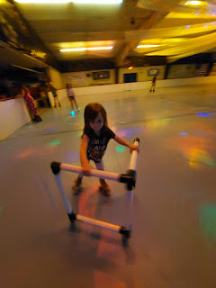

It's amazing what a little independence can do for you.

Video of her taking off on her own: (23 seconds)

https://photos.app.goo.gl/QMmcM6qs366zk2vU8

And just a few minutes later, she was ready for some tricks!! She'd skate one-handed for a bit, and then twirl the helper around behind her, etc.

Video of Gwen's tricks: (23 seconds)

https://photos.app.goo.gl/CGGSQ19p2V9t4sK56

We skated for about 90 minutes before Amber was scheduled to come pick us up. After we took off our skates, I asked Gwen to take her "helper" over to a tiny little girl in the middle of the rink and offer it to her for the last 30 minutes of the session. I had been watching her dad all stooped over trying to help her skate for several minutes already. Gwen confidently marched out onto the floor to give it to the little girl, while I took a picture.

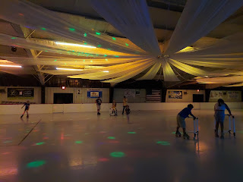

And wouldn't you know it, the moment that the little girl grabbed ahold of the "helper", she took off confidently and began skating 10x faster than what she did before with her dad's help. Amazing. :)

When we got home, the ribs were almost done. Yummm!!

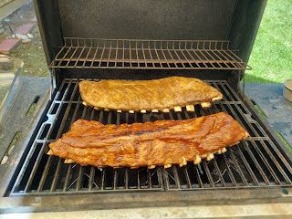

Amber whipped out a fried mashed potato dish with spices and salt and a tzatziki style dip on the side. Dinner was a success the moment that we convinced Gwen to try some of the meat. Her eyes got as big as saucers as she exclaimed, "THIS is the BEST meat I've EVER had!!!!!" She wanted seconds and even thirds. Benson just glowed. He said to Amber and me, "It's one thing if the grownups tell you it's delicious. But the kids will tell you straight up if they like it or if they hate it."

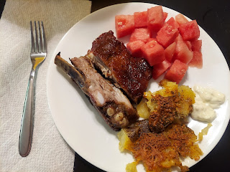

After the kitchen was all cleaned up, Benson built us a beautiful fire for s'mores in our firepit out back.

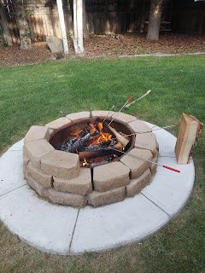

First, our neighbors, the Kloaks (straight across from us) came over to give us a patriotic dessert that Maria had made - oatmeal chocolate chip cookies, but with red/white/blue M&M's. We invited them to come out back with us, and they stayed for about a half hour or more.

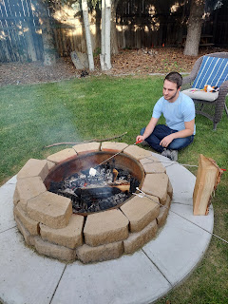

Amber grabbed the s'mores supplies earlier while Gwen and I were skating, including some Reese's PB "sections" instead of the usual circle shape. I made my dessert with that instead of the typical Hershey's bar and it was SO GOOD.

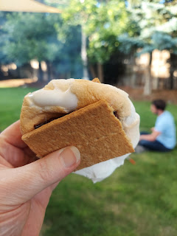

Gwen was just so happy to eat an ooey gooey golden marshmellow that Benson prepared for her.

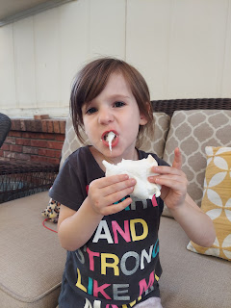

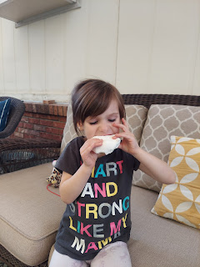

Amber munched as she relaxed on the swing . . .

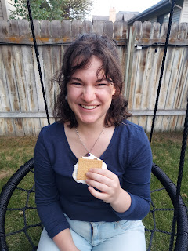

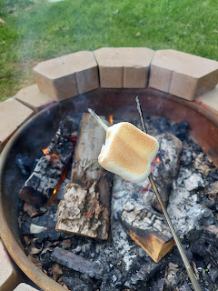

Next, we hollered over to the Parkinsons across the street (next door to the Kloaks) to invite them to join us. Kim and her daughter, Mady, came over and stayed for a good long while. We laughed and chatted until it was quite dark. I learned something new about Kim that evening: she has an obsession with marshmallows. Apparently she has her own secret stash at her house . . . and she told us that if she walks down the grocery aisle where the marshmallows live, she can SMELL them through the bag!! She can't resist buying some every single time, ha ha.

We handed her one of the open bags of giant marshmallows and that made her very happy. :)

Kim (left) and Mady (right)

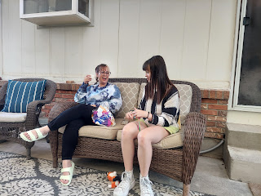

Something new that Gwen wanted Benson to do over and over that evening was the classic Underdog while she was on the swing.

Video of Benson and Gwen: (31 seconds)

https://photos.app.goo.gl/D6HCiFDKf1t77h5H8

Thursday, June 29th:

I had a doctor check-up in the morning (all is well) and Amber went to pick Abby up from Cousin Camp around 11:30 a.m. She had been busy packing up the car all morning and was in the final stages.

She arranged with Weston to meet him down in Salt Lake City shortly after he flew in so that they could have a Date Night and Date Morning by themselves. They would be heading south the next day anyway for a family campout with Weston's whole family down in Manti, Utah. The plan included me taking care of the girls for that same night, and then Benson and I would drive them down to Utah and meet up for lunch the following day.

I got a surprise video call from Jack in their new apartment in Minneapolis. He showed me all the cars that were clutched in his arms. What a cutie! They are very happy so far and have already been to a couple of parks and a nearby swimming pool.

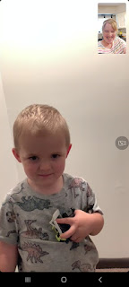

They are still without a car in Minneapolis, but the public transportation is great. Here they are, waiting for a bus to get home after a trip to the store for some supplies.

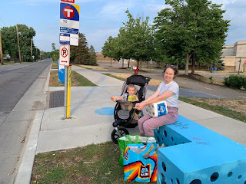

Kylie's step-mom, Nicole, sent me this DARLING photo of Avery playing in the water in their back yard across town. It could have passed for a centuries-old fountain in Italy as far as I was concerned . . . Avery is so blessed to have two doting sets of grandparents in her life.

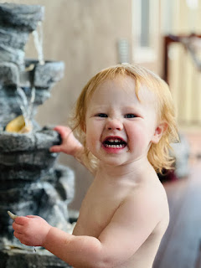

In the late afternoon, I took Abby and Gwen to Freeman Park, which runs along the Snake River in the NW portion of Idaho Falls. It connects to the area surrounding the Temple and the waterfalls, which are about a mile to the south. When I asked them if they wanted me to park closer to the playground or closer to some potential climbing trees, they shouted in unison, "The climbing trees!!"

But first they had to make a wish and blow some dandelion seeds all over everywhere . . . LOL

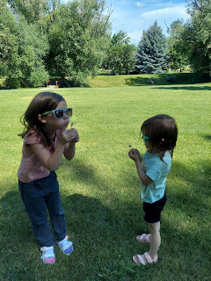

We played "Pooh Sticks" on the bridge over the creek . . .

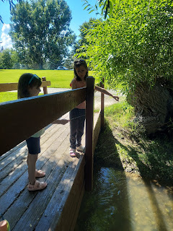

And then we found the perfect spot for wading.

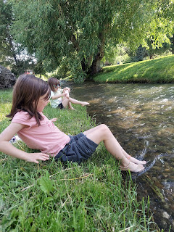

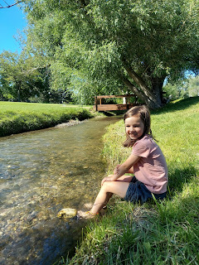

The girls had so much fun cooling off in the water, exploring around, and finding rocks to kersplash.

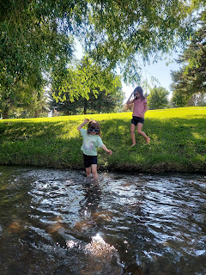

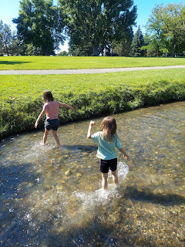

Video of Gwen and Abby (mostly Gwen) in the creek: (25 seconds)

https://photos.app.goo.gl/CWJzwaf5pVsywLmN8

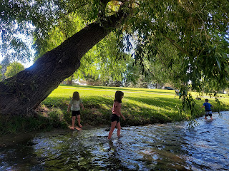

Gwennie spotted another dandelion across the creek, so she raced over to pick it, make a wish, and then spread some dandelion posterity across the land.

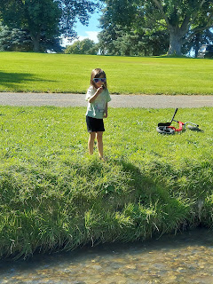

When they were ready to find some trees to climb, I noticed that Gwen had a hefty smear of mud on the side of her shorts.  I had her sit in the water to wash it off . . . she got a kick out of that.

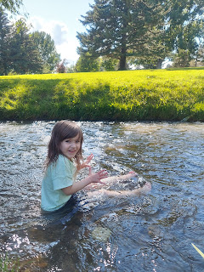

Time to find some big trees to climb . . .

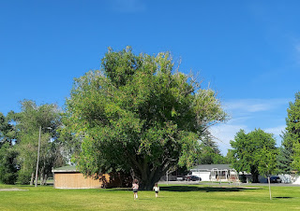

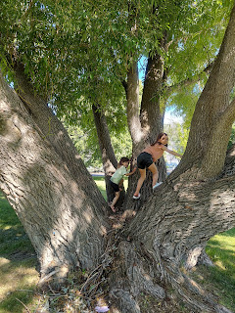

Abby in her happy place . . .

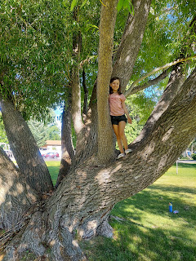

Gwen wanted me to push her in the swing for a little bit while Abby continued tree-climbing. Once Gwen was done, she had a hilarious sound effect to re-enact for me: the screechy sound the swing made as it went back and forth.

Video of Gwen's sound effects: (11 seconds)

https://photos.app.goo.gl/EEeN6HmPXzuc8ch77

The girls found tree after tree to climb as we circled back to the car.

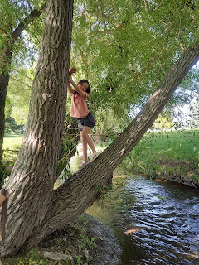

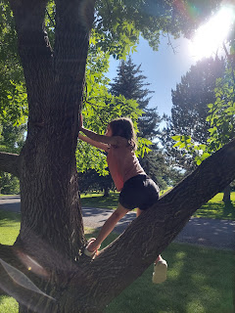

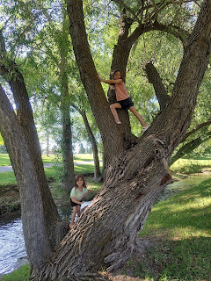

They even found a set of drums out in nature!!

Video of their bongo drums: (14 seconds)

https://photos.app.goo.gl/rq97qUoHQzXE592f8

For the ride home, I made Gwen's booster seat waterproof by emptying out the last few water bottles in the trunk and laying down the plastic wrapping for her to sit on.

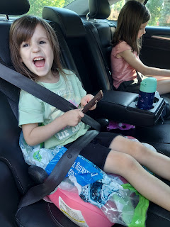

They each bathed and got all squeaky clean, played on the Switch for a few minutes, and then off to bed.

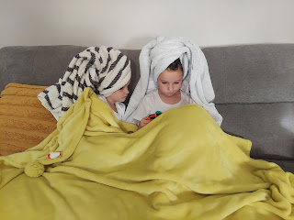

Friday, June 30th:

Everyone woke up a little early so we could get out the door and head down to Utah. While the girls were getting dressed and eating breakfast, the pest control technician arrived to inspect the mice bait stations for me. (The stations are locked and require a special key to open them up and look inside.)

The previous week when he came, we had a shocking discovery downstairs. I thought we were winding down with the mice infestation, but when he opened the bait stations up we noticed quite a bit of activity in several of them. I was DEVASTATED. It was like we were starting all over again with a whole new batch of mice, but where and how were they getting in??

Mike, the technician, volunteered to take a lap around the exterior to see if he saw anything unusual or telling. He found something right away on the south side of my house. There is a metal door at the base of the double chimneys and it wasn't fully closed.

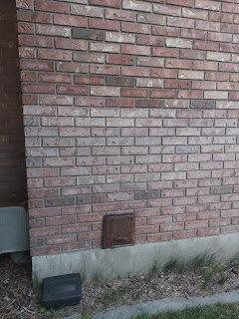

He opened it up and found a lot of mice droppings inside, including bright green and red poops, indicative that they were recent poops after they ate the bait that we had set up downstairs. Blech.

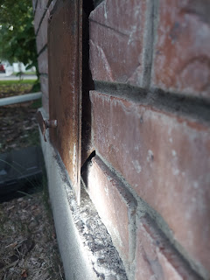

He advised me to seal the door off using steel wool. I was concerned that if I trapped any mice indoors, then that could be potentially a very bad thing (ewww) . . . He theorized that with my neighbor's jungle next door and her hoarding habits, there are probably so many mice at her house that they have begun to migrate (over to my house) in order to not be so crowded. YUCK. And clearly they found an entrance to what they saw as a Party House.

It took me a whole day to get brave enough to seal off the entrance/exit. Kim, my neighbor and friend, is who ultimately convinced me to just

do it

.

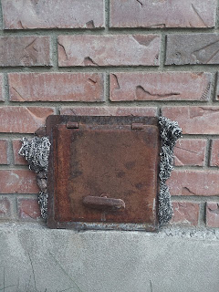

The technician suggested that I set out a small water source downstairs to draw the mice to it in their final stages of dying, since they wouldn't be able to go outside in search of fresh water. I decided that the utiity room would be a good spot, since nobody ever goes in there and I could check on it every day discreetly.

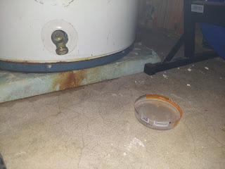

That's when I noticed a new problem. The water heater was leaking ever so slightly . . . not only did I see a rusty, wet dribble at the base, but the blue band around the bottom had a glisten to it as well. I let Scott know the next morning and we are getting things set up to replace the water heater later next week. He said it will only get worse from here, not better, and we don't want a disaster to happen when I go back to Italy. The unit is 17 years old, so I guess it's just the right time to replace it.

Two pieces of good news: I never saw any mice the whole week, including no new mice poops anywhere. And then, when the tech came back on Friday (the day we were getting ready to drive down to Utah), he saw very minimal nibbling in one of the bait stations. We believe that this may have occurred in the 36 hours from when he last came and when I got brave enough to seal off the chimney flap door. So I THINK (crossing fingers) that our mice problem is officially over. THANK GOODNESS. What an ordeal this has been . . .

The girls did great on our drive down south, and Benson offered to drive, so that freed me up to be more available to interact with the girls during that time. We ended up meeting Amber and Weston in Farmington, slightly north of SLC. We met at a meat-lover's restaurant called Tucano's.

Their date went splendidly, and their time alone allowed them to visit the Salt Lake City Library (with a giant Chess game board), eat at an Ethiopian restaurant for dinner, rent a couple of scooters and ride to a fun restaurant for breakfast, and then do a little shopping before joining us for lunch.

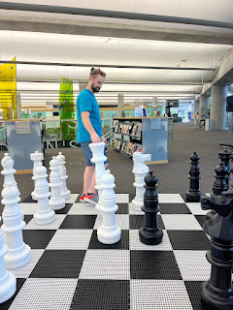

At the restaurant (Tucano's), you have a small cylindrical block that you keep at the edge of the table to let the servers know if you want more food brought around or if you need a break. Red facing up means stop bothering us. Green means hurry up and feed us. (If you look closer, you can see the red/yellow/green block on the table behind the server.)

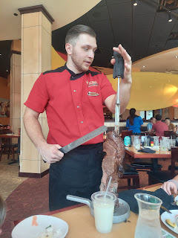

Someone will be walking around with a giant skewer of beef, or chicken, or brisket, or sometimes grilled veggies or grilled pineapple. You can say yes, or simply decline and they will move on to the next table with the "green side up". They also had a fantastic salad bar buffet, with all sorts of fancy things. (salad fixings, soups, cheesy pull apart bread, sushi, etc.)

Once we were all sufficiently stuffed, we walked back to our car while Weston retrieved their car and drove over to where we were waiting.

L to R: Abby, Amber, Benson, and Gwen

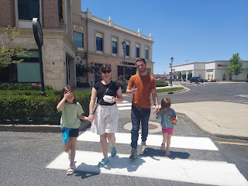

It was toasty and hot outside, which made it slightly easier to say goodbye and not drag it out. Poor girls in the back seat, though. Adding Weston and his luggage (minimal but it still took up space), plus all the extra items Amber was hauling home from Grandma and Grandpa's house, made for a VERY packed area surrounding Abby and Gwen. There was even a giant brown grocery bag full of supplies for s'mores in between them, blocking their view of each other. On the bright side, maybe that would act as a boundary to cut down on any potential bickering . . .?

As far as we know, they made it to the campground down in Manti and have been having lots of fun so far. We did hear from them Saturday briefly, as they had access to Wi-Fi when the whole crew went into town to do a service project for Grandma Bone, Kathy's mom.  There are approximately 25-30 family members at the campout.

Benson and I drove over to Wellsville, Utah, just outside of Logan, so he could see if the car that he really wanted online was actually what he wanted. It was parked out in the weeds next to the owner's house, and morning glories had intertwined their vines with the tire rims and into the front grill, ha ha.

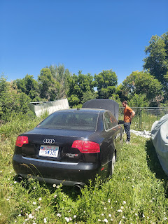

The owner, Tanner, is active military (US Army) so they had several jokes to fling back and forth, as well as curious questions to ask about each other's career paths. We could tell right away that Tanner was a good guy, as he was very honest and upfront about the car, with its quirks and also its more promising features. His reason for selling it was because he had more projects than he had time to work on them, so this "project" needed to go.

Benson knew ahead of time that it had a misfire, but he is also very comfortable fixing a problem such as that. He borrowed some tools from Ben (Kim's husband) and was prepared for a variety of issues to get it up to par for the drive home.

Problem #1 was that it wouldn't drive, ha ha. The battery was mostly dead and this was as far as he got on the test drive.

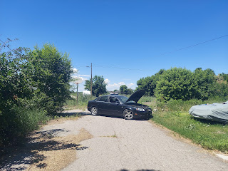

Tanner brought out his charging "box" and together they did some tinkering under the hood for a few minutes.

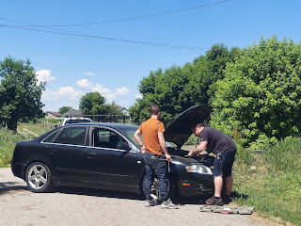

Soon, Benson was able to take it for a spin. He came back with a smile, confident that even though it wasn't perfect, it was good enough. He paid $3600 in cash for it and we were on our way. Tanner gave him the title, along with some extras: a turbo unit that had not been installed yet (worth about $800) and four new coils for whenever Benson wanted to install them to fix the misfire.

We drove about 30 minutes into our 2 1/4 hour drive home, when Benson called me (from his new car in front of me) to tell me he wanted to pull over at the next exit to get under the hood. It was nothing urgent or dangerous, but he wanted to replace one of the coils (#2) to see if it would improve the accelaration, which was a bit sluggish.

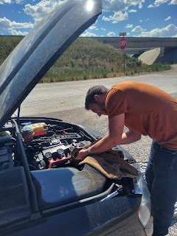

I handed him a few things from my trunk, just like a surgical assistant would: an old dirty rag, a jug of motor oil, a jug of coolant to top it off, etc. After maybe 15 minutes we were back on the road. As we drove up the on-ramp to get back on the freeway, he rolled down his window to give me a giant thumbs up. Success. :)

We made it the rest of the way home without any further incident. He spent the evening washing and detailing the outside from the top to bottom, something he LOVES to do. This 2007 Audi A4 Quattro is his new little baby and he plans to take very good care of it.

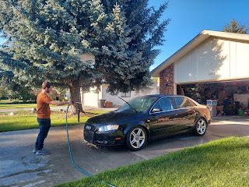

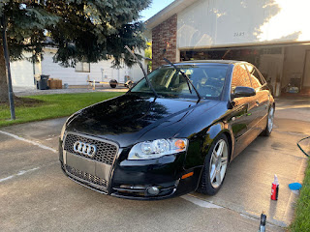

Saturday, July 1st:

Benson and I spent a good portion of the day clearing out the Grandchildren Guest Room in preparation for new carpet that will be installed on Wednesday this coming week.

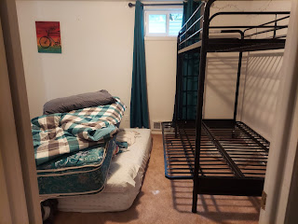

I had already emptied out all the toys, but I needed help disassembling the bunk bed to get it out of the room.

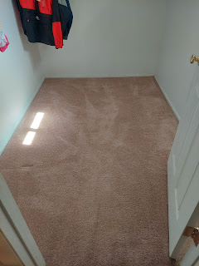

Benson is an excellent helper and handyman to have around. It's like he has some of his father's genes or something . . .

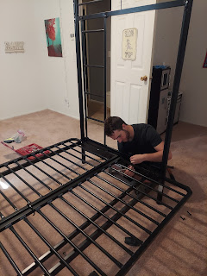

We pulled up all the old carpet and padding, carried it out to Dad's truck that we borrowed, and hauled it off to the dump. After this picture was taken, I vacuumed up all the decades' worth of dust under where the carpet had once been.

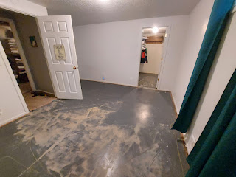

Another new problem surfaced as we were about to go to the dump. You might recall that back in February, my garage door didn't want to open or shut. I had a serviceman come take a look at it at that time. He adjusted the torquing mechanism as far as it would go, which made the door work again. But he warned me that it could last a few days or a few months, and that as soon as it started acting up again, it would be time to get a new motor. Well, that day has arrived.

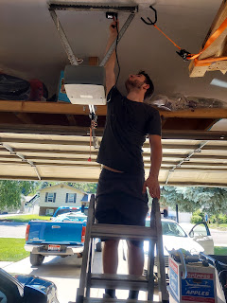

Benson had the thought to unplug the unit, wait a few seconds, then try again. It's working to open and shut . . . for now . . . but Scott ordered us a new motor and Benson will be installing it a few days from now.

Another problem that needed attention is this ugly scar on the wall downstairs. As we emptied out the bedroom, I had a light bulb idea to paint the room BEFORE the carpet arrives on Wednesday. There would be no better time than now and we've never painted it the whole time we've lived here (17 years). But how to go about fixing this hole in the wall? Jacob kicked a hole in it several years ago as a young teenager, patched it up himself, and then put a trash can in front of it to hide it, ha ha. We didn't know it existed for quite a while.

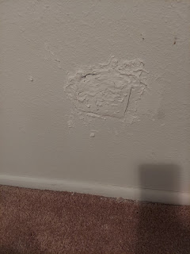

Scott told me a couple of ways to fix it, but also suggested that I have Ben come take a look. He came over Saturday night and made a plan to fix it with Benson's help, which they already did while I was at church Sunday morning. It looks so much better already!!

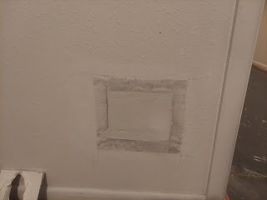

Benson went the extra mile and patched up all the other holes around the room (from hanging things over the years), using the sheetrock mud that Ben had prepared for the bigger patch-up job. I am so grateful to have Benson here with me, for so many reasons. Not only has he helped me with so many projects already, but he is just so pleasant and polite and nice to hang out with. We have really enjoyed being roommates and buddies these past few weeks. :)

A point that I have made recently, I would like to reiterate again: It is imperative to find joy even while you are experiencing stress. I have had quite a bit of stress this week, especially with things breaking and not working. But I choose to still see the glass as half FULL and find things to smile and laugh about each day. Granted, it's already in my nature to do so, but anyone can do the same thing, too. It's hard to keep things in perspective some days, and it may seem like the majority of the day is breaking down or failing miserably. It is ALWAYS worth it to look hard for something good, a golden nugget of joy, a blessing or a tender mercy, to balance out the stress and frustrations.

Put in the effort and then reap the rewards

.